*Florida International University*

*School of Computing and Information Sciences*

Software Engineering Focus

Feature Document

User Story ID 708

**Name:** Unassign Devices

**Team Member(s):** Leandro Gonzalez,Luis Herrnsdorf

**Project:** Smart Stormwater (Smart City System) 2.0

**Product Owner(s)**: Emilio Lopez

**Mentor(s)**:

**Instructor**: Masoud Sadjadi

**User Story Name:**

* Description: As an admin, I want to be able to unassign a device from a particular sub-user so that I can manage the devices that my sub-users can have access to

Acceptance Criteria

* When displaying the devices assigned to the selected user in the sub-users page, admins can click on a ‘Remove’ button next to each device
* The device assignment will be removed in the database
* The devices table will reflect the changes, as the removed device will no longer appear for that sub-user

**Use Case**

* Name: Unassign Device
* Actor: Admin
* Preconditions: Admin is logged in
* Description: On the main page, the admin clicks on the ‘Users’ tab on the side panel. On the ‘Users List’ table, the admin selects a user by clicking on it. A ‘Devices per User’ table on the bottom of the screen shows all the devices assigned to the selected user. The admin click on a Remove button next to a device. The device will be removed from the list of assigned devices to that particular sub-user

**Use Case Diagram**

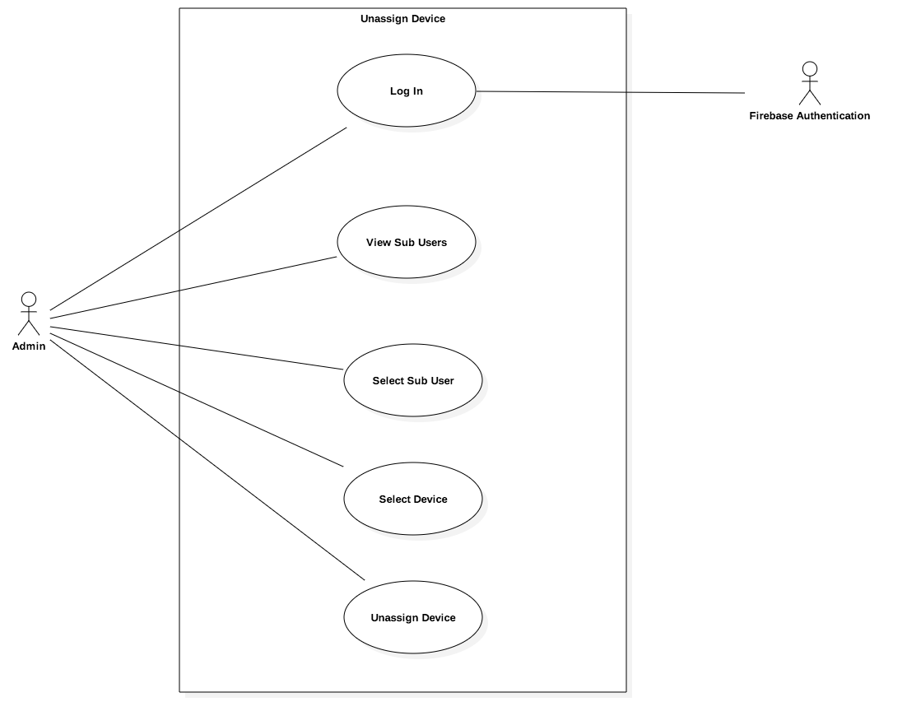

**Sequence Diagram**

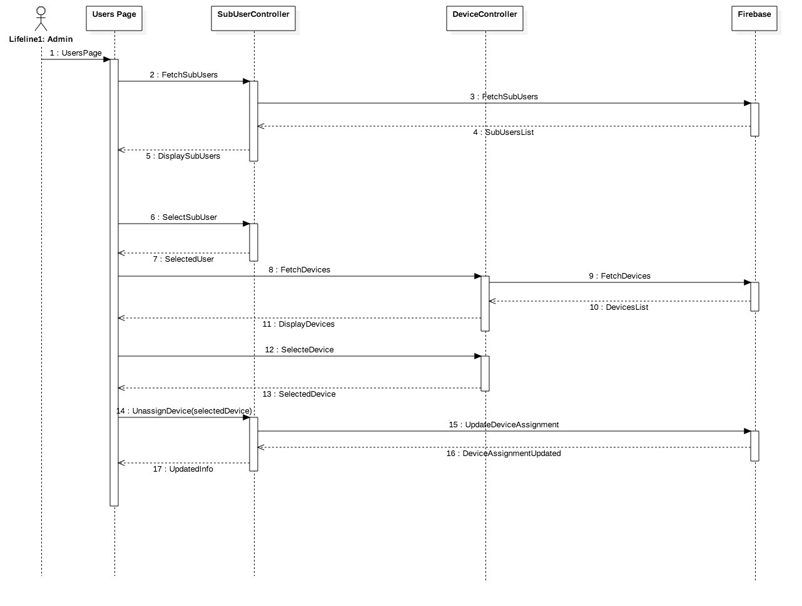

**Class Diagram**

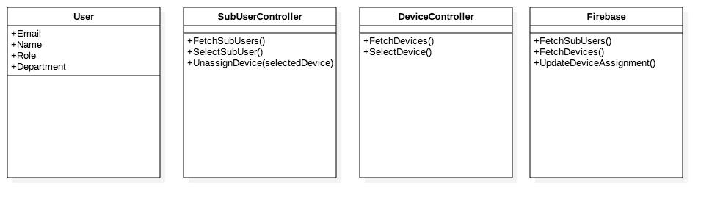

**Unit Test**

* Test case ID: UnassignDevice001
* Description/Summary of Test: Admin removes device from list of devices assigned to a sub-user
* Pre-condition: Admin is logged in
* Expected Results: The removed device will be removed from the list of devices assigned to the selected sub-user
* Actual Result: The removed device no longer appears as assigned to the selected user
* Status (Fail/Pass): Pass

**Visual User Guide**

